

India AI
Date: 6 February 2026
Event Details

- Date :- 6 February 2026
- Time :- 5:00 PM to 6:00
- Venue :- Online Mode
- Professional Volunteer :- Dr. Sachin Gajjar
- Student Volunteer :- Harmit Prajapati
- Total No of Participants :- 8

Session Summary

Introduciton:-
The event focused on Artificial Intelligence (AI) initiatives across leading academic institutions in Gujarat. The session brought together representatives from IIIT Vadodara, Nirma University, Pandit Deendayal Energy University (PDEU), Dhirubhai Ambani Institute of Information and Communication Technology (DAIICT) and Parul University. The objective of the event was to create a collaborative platform for sharing institutional AI initiatives, fostering innovation-driven partnerships, and strengthening the regional AI ecosystem through academic and industry engagement. Artificial Intelligence (AI) has emerged as a key driver of innovation in healthcare, education, manufacturing, governance, and sustainability, enabling data-driven decision-making, automation, and the creation of intelligent systems with real-world impact. The event aimed to bring together academic institutions to exchange perspectives on ongoing and planned AI initiatives, including academic and research activities across institutions. Each participating representative was invited to share a 5–10 minute overview of the AI initiatives being undertaken at their respective institution.

Objective of the event:-
The key objectives of the IEEE Gujarat Section initiative were: - To bring together leading academic institutions to exchange perspectives on ongoing and planned AI initiatives. - To showcase AI-related academic programs, research contributions, innovation activities, and entrepreneurial efforts across institutions. - To promote entrepreneurship and innovation in AI through structured inter-institutional collaboration. - To explore joint workshops, research projects, startup incubation support, and funding opportunities under national initiatives such as the India AI Mission. - To build a strong AI collaboration network under the IEEE Gujarat Section framework.

Opening Remarks:-
The session commenced with opening remarks by Prof. Dharmendra Singh, Director, IIIT Vadodara. In his address, he highlighted the transformative potential of Artificial Intelligence across sectors while emphasizing the importance of responsible, ethical, and cautious use of AI technologies. He spoke about the need for balanced adoption, ensuring transparency, accountability, and societal benefit while advancing innovation. His remarks set the tone for a meaningful and forward-looking discussion among participating institutions.

Institutional Presentations and Highlights

Nirma University :-
Dr. Sachin Gajjar, Nirma University presented a comprehensive overview of its AI ecosystem, including workshops, research projects, industry collaborations, and defense-related initiatives. He discussed about the organization of AI workshops, including an AI Agents Workshop conducted in collaboration with IEEE Young Professionals and IEEE Gujarat Section, with 185 participants and financial support from IEEE. - Industry collaboration with EdgeImpulse Inc., involving Edge AI development boards and projects such as Keyword Spotting, Weather Monitoring Systems, and Gesture-Based PC Control. - Participation in defense-oriented initiatives such as the Tri Services Academia Technology Symposium (TSATS), focusing on intelligent drone surveillance systems using multi-modal machine learning on Edge AI devices. - Research contributions across domains such as VLSI, Communication, Agriculture, Medical Applications, Remote Sensing, and Vision-based real-time detection. - Deployment of AI models on Edge AI platforms including NVIDIA Jetson Nano, Orin Nano, Intel UP Squared, Intel NCS, Xilinx Kria, and Raspberry Pi. The presentation emphasized applied research, entrepreneurship opportunities, real-time deployment, and interdisciplinary collaboration aligned with IEEE’s innovation mission.

IIIT Vadodara:-
IIIT Vadodara presented its research-intensive ecosystem in Artificial Intelligence and Machine Learning. The institute conducts specialized academic and capacity-building programs such as AICTE-supported PG Certificate Programs in Artificial Intelligence and Faculty Development Programs under national initiatives like ATAL Academy, focusing on deep learning and practical AI implementation. The institute also organizes international conferences such as HACER (AI for Healthcare and Climate Resilience), highlighting interdisciplinary AI applications addressing societal challenges. Faculty research at IIIT Vadodara spans deep learning, computer vision, intelligent systems, data science, and applied AI, with active engagement from the institute.

Pandit Deendayal Energy University (PDEU):-
PDEU highlighted its strong engagement in AI research and academic dissemination through international conferences and workshops that covers machine learning, computer vision, signal processing, intelligent systems, and human-computer interaction.
The university emphasized AI applications in energy systems, sustainability, industrial automation, smart grids, predictive analytics, and data-driven optimization. The focus remains on interdisciplinary and industry-relevant AI research aligned with energy and infrastructure domains.

DAU:-
Dhirubhai Ambani University shared its strong foundation in AI, Machine Learning, and Data Science research. The institute offers advanced academic programs such as M.Sc. in Data Science and specialized tracks within M.Tech programs that emphasize machine learning and intelligent systems.

Parul University:-
Parul University shared its structured academic and research initiatives in Artificial Intelligence and Data Science. The university has established a strong academic pipeline through programs such as B.Tech in Artificial Intelligence & Data Science, M.Tech in Artificial Intelligence & Data Science, B.Sc. IT (AI), and Master of Design in AI, ensuring multidisciplinary integration of AI across engineering, computing, and design domains. The institution also organizes international conferences which brings together researchers, industry experts, and policymakers to discuss scalable AI solutions for industry and society. The university emphasized innovation labs, hackathons, startup incubation activities, and industry-aligned skill development initiatives to promote entrepreneurship in AI.

Key Discussion Points:-
The interactive session led to meaningful discussions on: - Formation of an IEEE Gujarat Section AI collaborative forum. - Organization of joint IEEE-sponsored workshops, hackathons, and faculty development programs. - Submission of collaborative research proposals to national and international funding agencies. - Promotion of AI-based startups and innovation under the IEEE Entrepreneurship & Innovation initiative. - Student internships, and mentoring programs across institutions. Participants appreciated the IEEE platform for enabling structured academic-industry interaction and regional networking.

Outcomes of the Event:-
The event successfully: - Strengthened networking among leading AI institutions in Gujarat. - Identified opportunities for joint IEEE initiatives in AI and innovation. - Encouraged entrepreneurship-driven AI applications. - Established a foundation for future collaborative programs under IEEE Gujarat Section. It was proposed that periodic meetings and thematic AI sessions be conducted under IEEE Entrepreneurship & Innovation to sustain momentum.

Conclusion:-
The online discussion organized by IEEE Gujarat Section under the IEEE Entrepreneurship & Innovation group, served as a significant step toward building a collaborative and innovation driven AI ecosystem in Gujarat. The session effectively showcased institutional strengths and opened avenues for research partnerships, entrepreneurship, and IEEE-led initiatives in Artificial Intelligence. The event concluded with a collective commitment to advancing AI education, research, and innovation through coordinated efforts under the IEEE platform.

Photographs

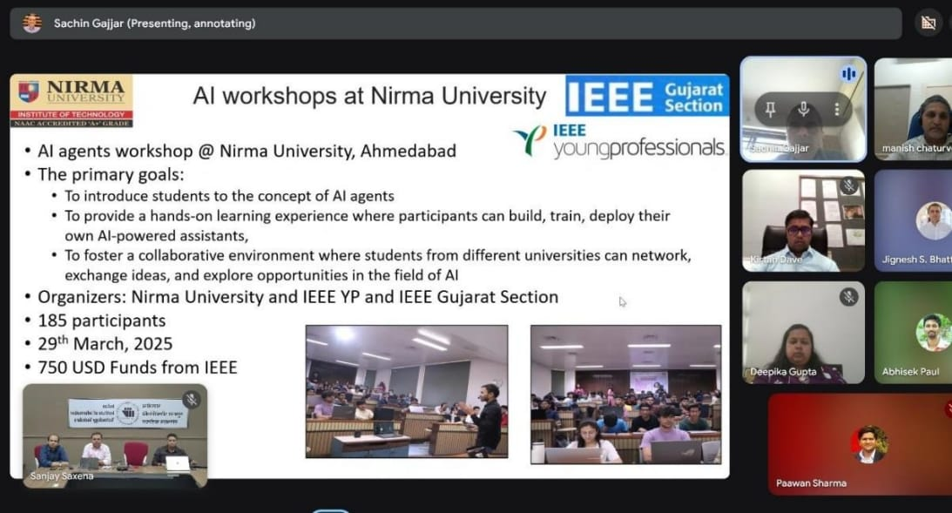
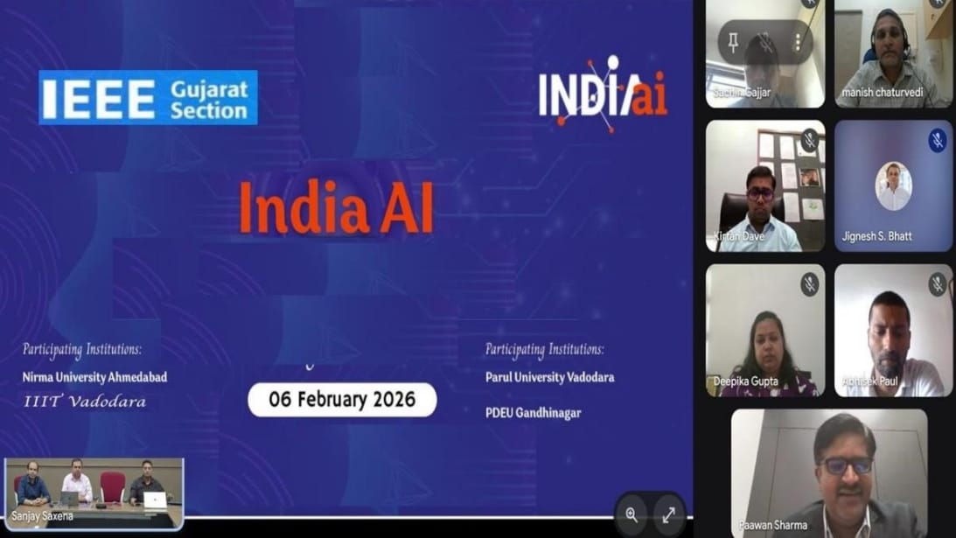

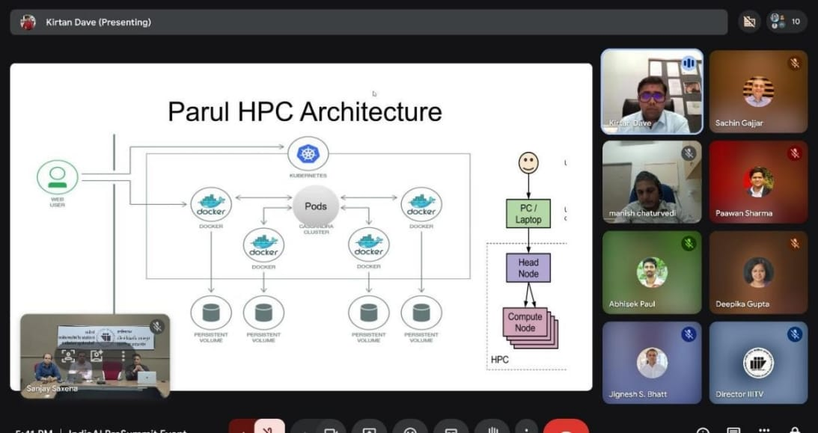
Submitted By:

- Name :- Dr. Sachin Gajjar, Chair-IEEE Entrepreneurship & Innovation Group , IEEE Gujarat Section
- Designation: Professional Volunteer
- Sign :-

(Note: Report should be of only 1-2 Pages max)

