

Laracon India 2026
Date: 31/01/2026 to 01/02/2026
Event Details
- Date: 31st January 2026 to 1st February 2026
- Time: 08:00 A.M. to 06:30 P.M.
- Venue: Gujarat University Conventional & Exhibition Center, Ahmedabad, Gujarat
- Professional Volunteers: 27
- Student Volunteers: 70
- Total No of Participants: 1100

Session Summary

Laracon India 2026 was a two-day conference organized with the objective of bringing together the Laravel developer community to share knowledge, explore emerging trends and strengthen collaboration within the ecosystem. The conference highlighted how modern software is shaped by clear design principles, reliable architecture and responsible use of artificial intelligence, with a strong emphasis on developer experience as well as long-term sustainability.

Building on this vision, the event featured insightful talks and live demonstrations by Taylor Otwell creator of laravel along with other renowned international and Indian speakers, including Jess Archer, Nuno Maduro, Freek Van der Herten, Neel Shah, Tirth Patel and others. Through real-world examples along with practical showcases, where speakers illustrated how thoughtful design decisions, performance-focused approaches and responsible use of AI tools contribute to creating scalable and maintainable software. In parallel, initiatives such as LaraConnect enhanced the overall experience by fostering meaningful networking and collaboration among participants.

Beyond technical learning, the conference emphasized creativity, community engagement and a forward-looking perspective. One of the highlights was the showcase of a robot, which drew significant attention and symbolized the growing intersection of innovation, automation as well as real-world technology. A reflective panel discussion offered valuable insights into the evolution and future direction of the Laravel ecosystem, highlighting the importance of collaboration between developers along with the core team. With strong participation from developers, professionals along with enthusiasts, Laracon India 2026 successfully delivered a balanced and impactful experience of learning, engagement and inspiration.
Photographs

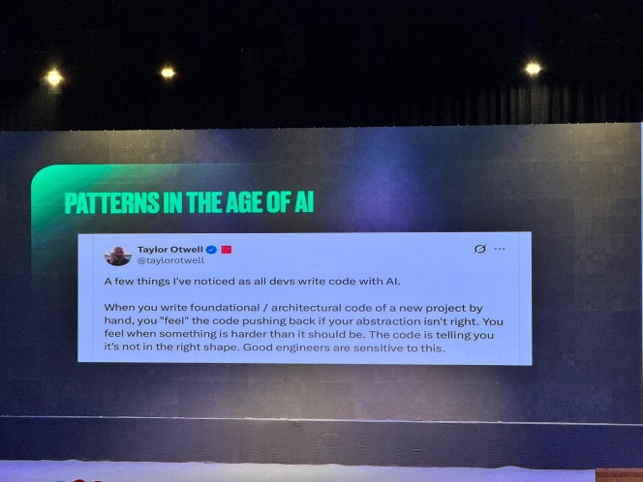
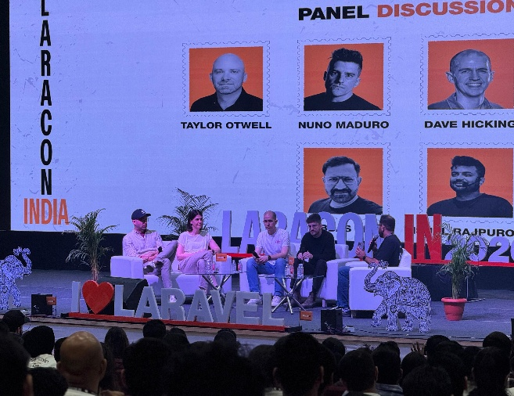
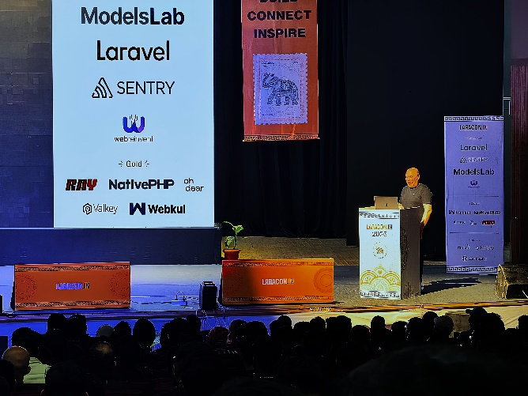

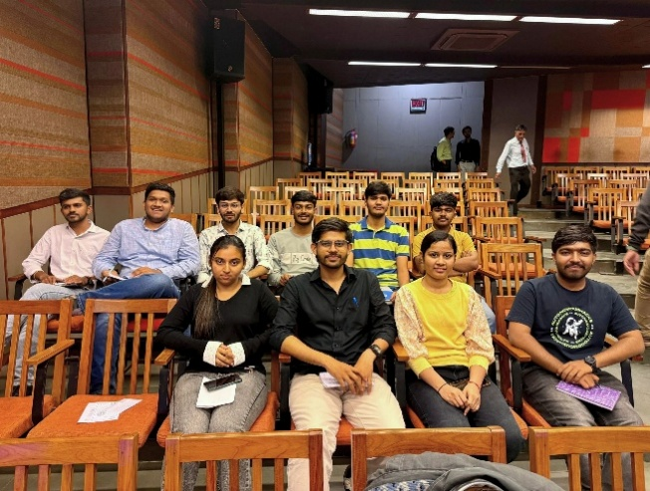

Submitted By:
- Name: Dr. Satvik Khara
- Designation: Professional Activity Chair, IEEE Gujarat Section

