

Event Title
Date: 16-02-2026
Event Details
- Date – 30 – 31 January, 2026
- Time – 9.00 am to 5.00 pm
- Venue – Adani University
- Professional Volunteers – Dr. Alok Kumar Singh
- Student Volunteers – Dharm Saliya, Ashish Shrivastav, Priyanshi Naghera
- Total No of Participants – 280+

Session Summary
The Drobotics Conclave 2026, held at Adani University, Ahmedabad, on January 30–31, was a landmark national summit bridging the gap between academia and the robotics industry. Attended by over 280 participants from 20+ institutions, the event featured key addresses from industry leaders like Shri Sudipta Bhattacharya and Prof. Kavi Arya, emphasizing indigenous innovation and project-based learning.

Highlights of the Conclave

Day 1: Focused on drone-centric warfare, startup ecosystems, and hands-on workshops in wireless robotics and UAVs.

Day 2: Explored advanced trends in Physical AI and industrial robotics, moving from theoretical insights to practical application.

Competitions: The event culminated in the Robo Race and Maze Solver challenges, where 37 teams competed for a ₹1,00,000 prize pool.

Supported by Adani Defence and Aerospace and GUJCOST, the conclave successfully fostered a collaborative environment for India’s future "warrior engineers" to develop scalable, responsible technological solutions.

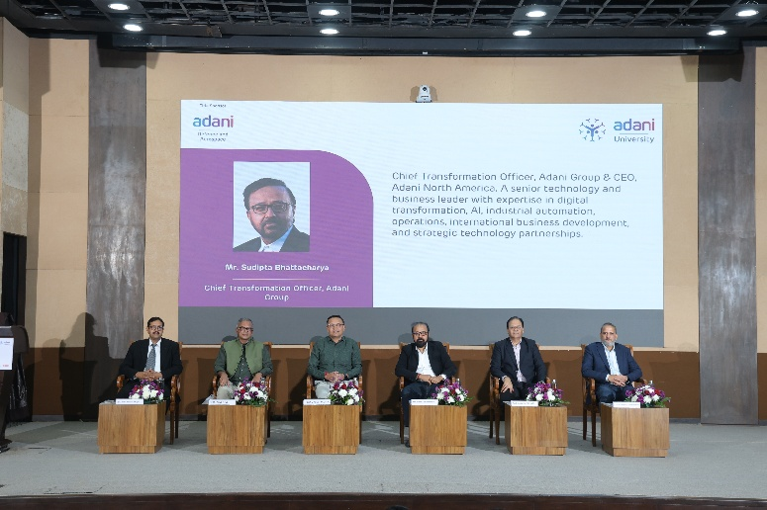
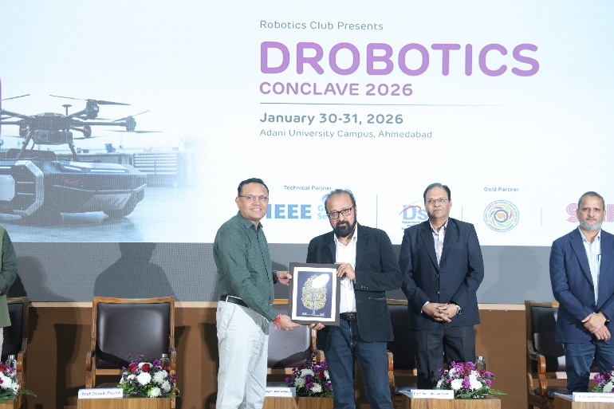
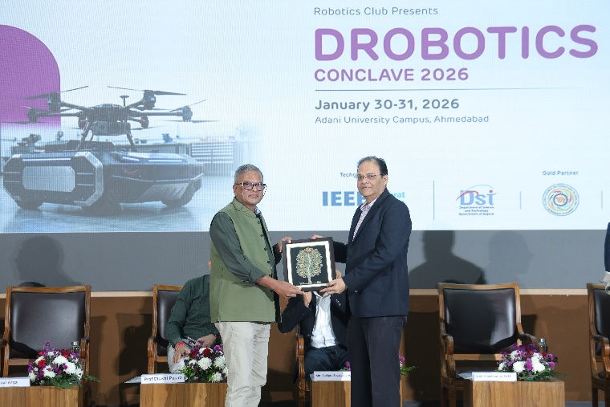
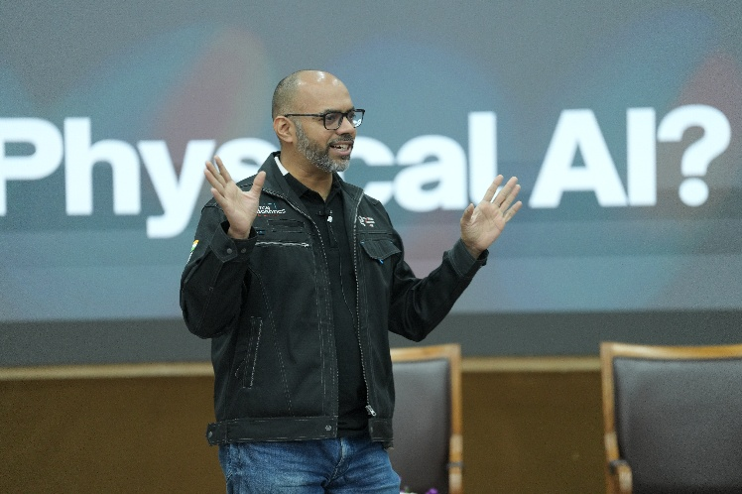
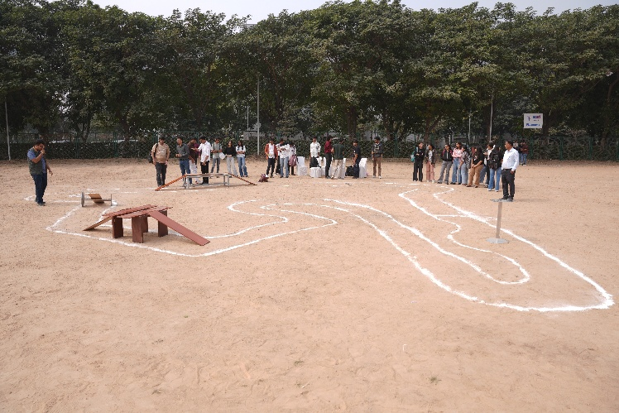
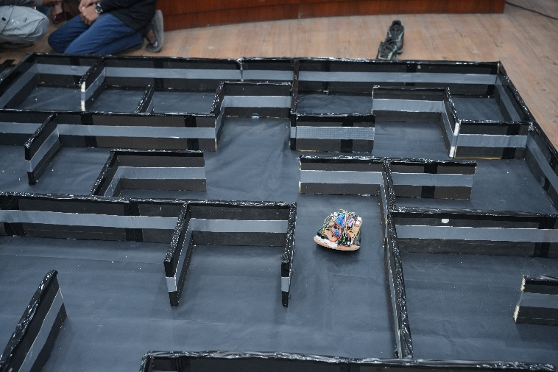
Photographs
Submitted By:

